Test Case: tc001_SPX_Dev5_Crear_Solicitud_Articulo_Almacen
Step 1 - Enter username and password and click to button Enter : Credentials Entered
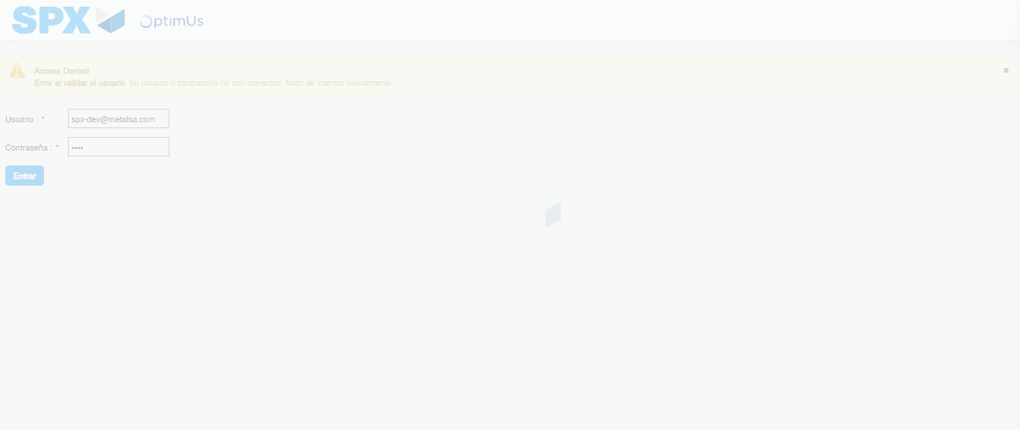Image file-name: QC_Testing-tc001_SPX_Dev5_Crear_Solicitud_Articulo_Almacen-1787932067599

Step 2 - Select to UEN and Access to Request for a New Inventory Item : UEN Correctly selected and Correct access
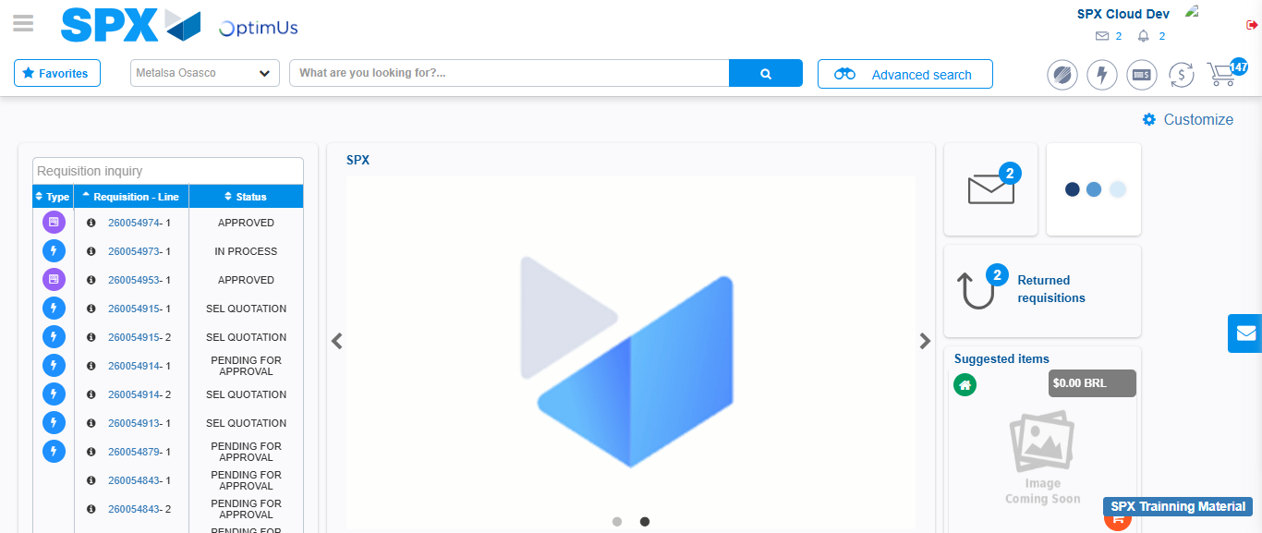Image file-name: QC_Testing-tc001_SPX_Dev5_Crear_Solicitud_Articulo_Almacen-1787932092906

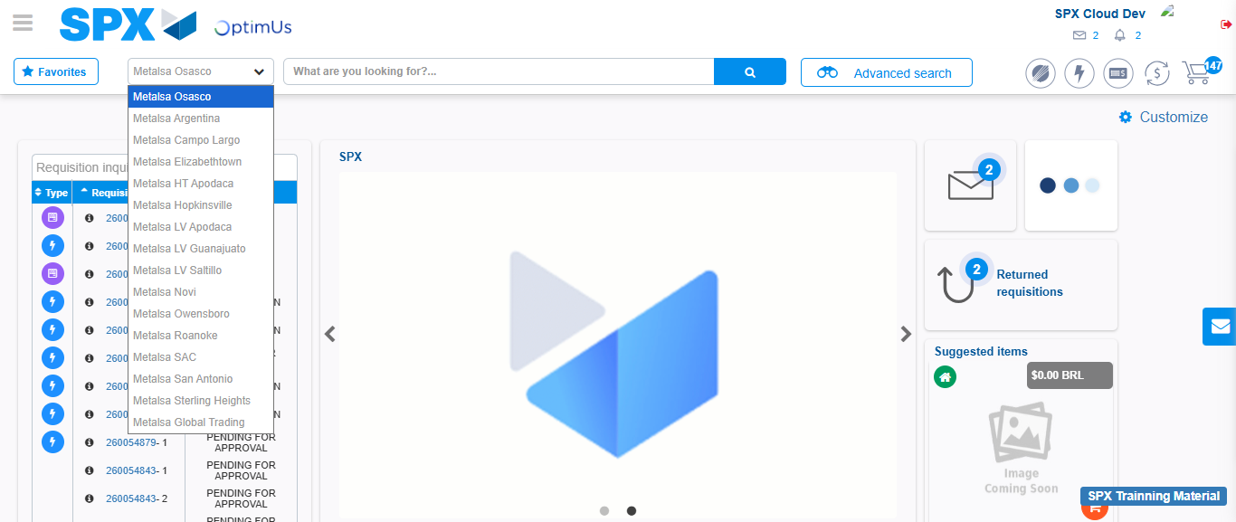Image file-name: QC_Testing-tc001_SPX_Dev5_Crear_Solicitud_Articulo_Almacen-1787932093422

Image file-name: QC_Testing-tc001_SPX_Dev5_Crear_Solicitud_Articulo_Almacen-1787932121102

Step 3 - Select options first section : Options seleted correctly
Image file-name: QC_Testing-tc001_SPX_Dev5_Crear_Solicitud_Articulo_Almacen-1787932121336

Image file-name: QC_Testing-tc001_SPX_Dev5_Crear_Solicitud_Articulo_Almacen-1787932121521

Step 4 - Select options at Screen: Options seleted correctly
Image file-name: QC_Testing-tc001_SPX_Dev5_Crear_Solicitud_Articulo_Almacen-1787932121336

Image file-name: QC_Testing-tc001_SPX_Dev5_Crear_Solicitud_Articulo_Almacen-1787932121521

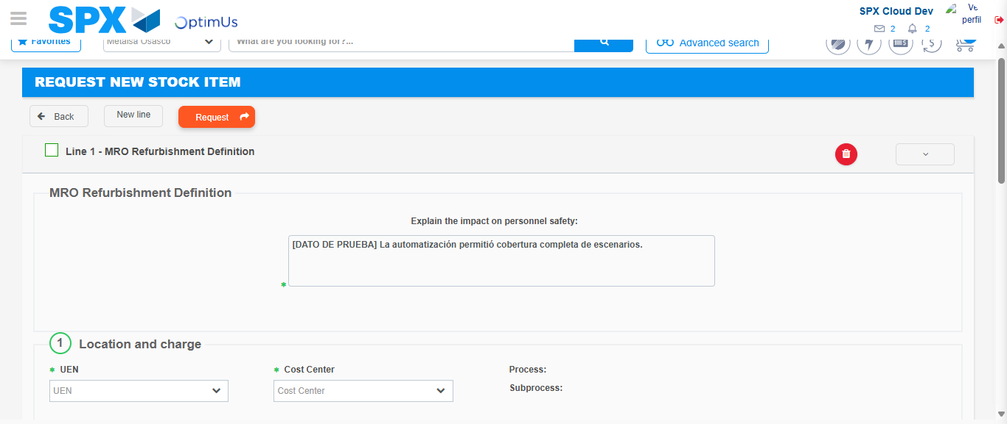Image file-name: QC_Testing-tc001_SPX_Dev5_Crear_Solicitud_Articulo_Almacen-1787932127818

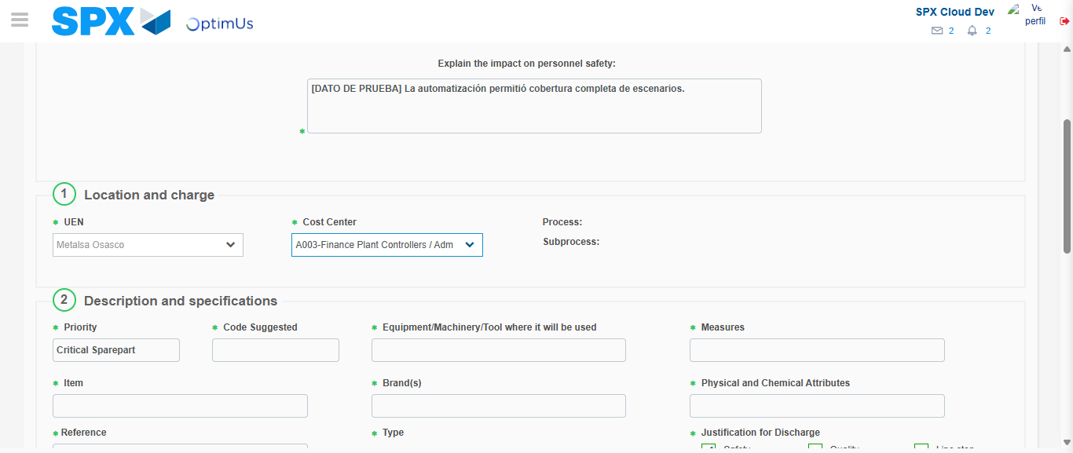Image file-name: QC_Testing-tc001_SPX_Dev5_Crear_Solicitud_Articulo_Almacen-1787932130649

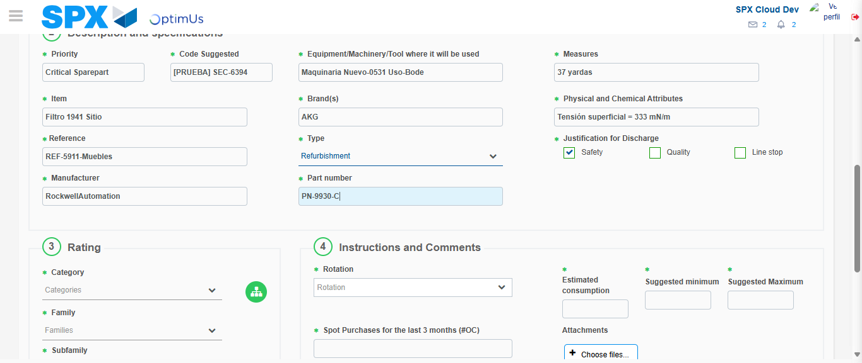Image file-name: QC_Testing-tc001_SPX_Dev5_Crear_Solicitud_Articulo_Almacen-1787932132569

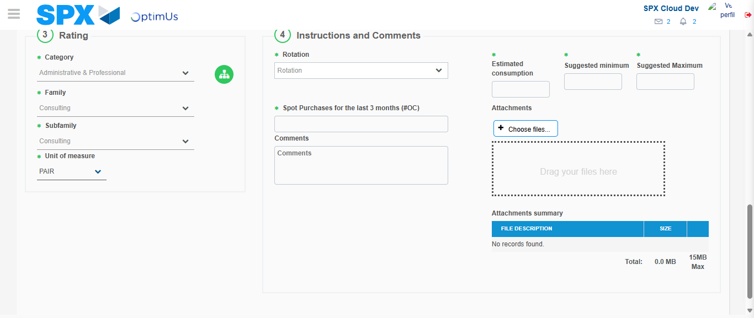Image file-name: QC_Testing-tc001_SPX_Dev5_Crear_Solicitud_Articulo_Almacen-1787932137587

Step 5 - Request New Item : Request Accepted
Image file-name: QC_Testing-tc001_SPX_Dev5_Crear_Solicitud_Articulo_Almacen-1787932092906

Image file-name: QC_Testing-tc001_SPX_Dev5_Crear_Solicitud_Articulo_Almacen-1787932093422

Image file-name: QC_Testing-tc001_SPX_Dev5_Crear_Solicitud_Articulo_Almacen-1787932121102

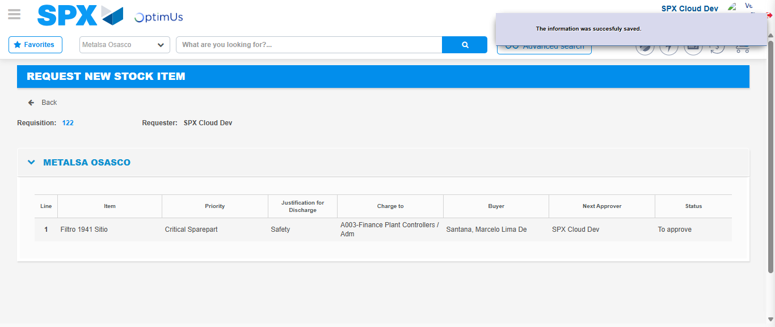Image file-name: QC_Testing-tc001_SPX_Dev5_Crear_Solicitud_Articulo_Almacen-1787932144922

Image file-name: QC_Testing-tc001_SPX_Dev5_Crear_Solicitud_Articulo_Almacen-1787932145109

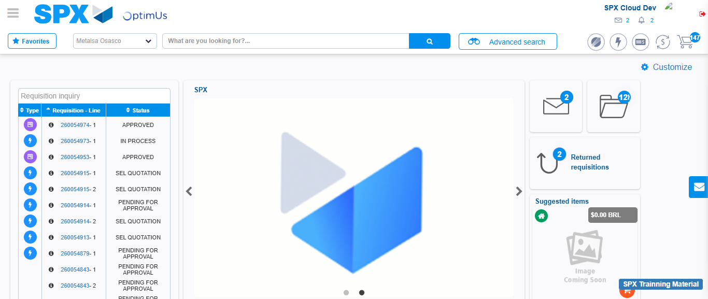Image file-name: QC_Testing-tc001_SPX_Dev5_Crear_Solicitud_Articulo_Almacen-1787932166521

Step 7 - Return to Main Page SPX : Return to Main Page SPX
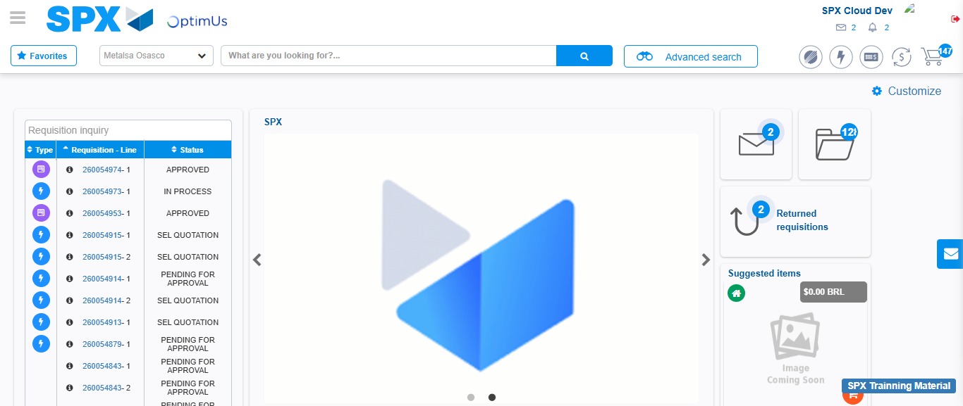Image file-name: QC_Testing-tc001_SPX_Dev5_Crear_Solicitud_Articulo_Almacen-1787932166808

